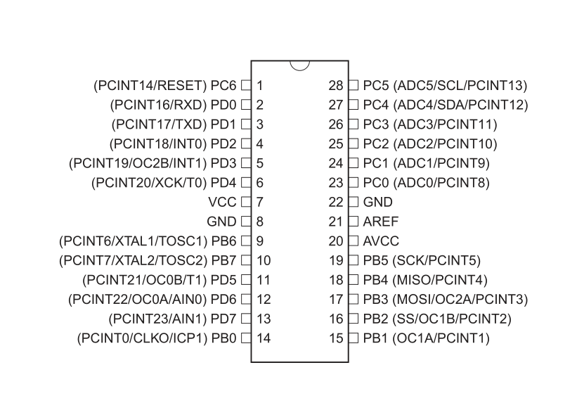

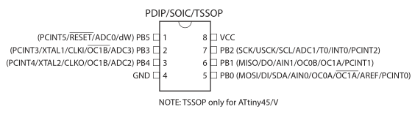

**Bus Pirate AVR programming connections**

|  |  |  |  |  |
| --- | --- | --- | --- | --- |
| **BusPirate Signal** | **AVR Signal** | **ISP pin (6)** | [**ATtiny2313 Pin**](http://www.atmel.com/dyn/resources/prod_documents/8246S.pdf) | [**ATmega328P pin**](http://www.atmel.com/dyn/resources/prod_documents/8271S.pdf) |
| GND | GND | 6 | 10 | 8 |
| +5V or +3.3V | Vcc | 2 | 20 | 7 |
| CS | RESET | 5 | 1 | 1 |
| MOSI | MOSI | 4 | 17 | 17 (PB3) |
| MISO | MISO | 1 | 18 | 18 (PB4) |
| SCLK/CLK | SCK | 3 | 19 | 19 (PB5) |